**PROJECT SUMMARY**

|  |  |
| --- | --- |
| Batch details | PGP-DSE June 2020 |
| Team members | Rishabh Choubey, Krupananda Gowda, Sarthak Niwate, Perumalla Naga Sai Venkatesh |
| Domain of Project | Environment Analysis |
| Proposed project title | Exhaustive Study of Air Quality in Indian (2015-2020) |
| Group Number | 03 |
| Team Leader | Perumalla Naga Sai Venkatesh |
| Mentor Name | Jayveer Nanda |

Date:

Signature of the Mentor Signature of the Team Leader

**TABLE OF CONTENTS**

|  |  |  |
| --- | --- | --- |
| Sr. No. | Topic | Page No |
| 1 | Overview | 1 |
| 2 | Business problem goals | 2 |
| 3 | Topic survey in depth | 3 |
| 4 | Critical assessment of topic survey | 4 |
| 5 | Methodology to be followed | 5 |
| 6 | References |  |

**PROJECT DETAILS**

1. **OVERVIEW (50-100 words)**

Indian Government is taking all efforts for the mitigation of air pollution in the country. Central Government has taken a number of regulatory measures for prevention, control and abatement of air pollution in the country.

The government has allocated 2,217 crores to tackle air pollution in 42 urban cities and introduced a voluntary vehicle scrapping policy. But it isn’t clear how the allocated 2,217 crores funds would be utilized to resolve the pollution crisis. In the previous budget, the government had announced 4,400 crores for clean air but there is no information on the public platform on how this fund was utilized.

On the other hand, the Budget document mentions that under “Control of Pollution”’ a total of 470 crores allocated for FY 2021-22. This includes providing financial assistance to Pollution Control Boards/Committees, funding to National Clean Air Programme (NCAP), mentions budget document. There are 122 cities presently under NCAP and the allocation for it is merely around 470 crores, which is clearly not enough.

Air Quality Index is a tool for effective communication of air quality status to people in terms, which are easy to understand. It transforms complex air quality data of various pollutants into a single number (index value), nomenclature and colour.

There are six AQI categories, namely Good + Satisfactory, Moderately polluted, Poor, Very Poor, and Severe. Each of these categories is decided based on ambient concentration values of air pollutants and their likely health impacts (known as health breakpoints). AQ sub-index and health breakpoints are evolved for eight pollutants (PM10, PM2.5, NO2, SO2, CO, O3, NH3, SOx, Xylene, Toluene, Benzene)

The analysis of AQI across different cities and stations will open the doors to take steps and acquire mitigation for reduction of air pollution.

1. **BUSINESS PROBLEM STATEMENT (GOALS)**
2. **Business Problem Understanding**

Across India over the last decade, air pollution has been a ubiquitous and visible concern with severe consequences for human health and well-being. An analysis of air quality index as per city and stations (per day and per hour) will open the doors to take sustainable steps to reduce air pollution in India.

1. **Business Objective**

* Prediction of Air Quality Index
* Clustering of Cities as per Air Quality
* Top 3 cities to implement solutions immediately

1. **Approach**

* For prediction of Air Quality Index: Regression
* Classification/Clustering
* EDA and Clustering

1. **Conclusions**

A sustainable transition calls for bringing in other values that matter to society in the immediate future, such as

* Good Health
* Clean Air
* Investing in clean technology and community driven change

1. **TOPIC SURVEY IN BRIEF (200-250 words)**
2. **Problem understanding**

The high burden of death and disease due to air pollution and its associated substantial adverse economic impact from loss of output could impede India's aspiration to be a $5 trillion economy by 2024. Successful reduction of air pollution in India through state-specific strategies would lead to substantial benefits for both the health of the population and the economy.

So, we are trying to analyze the AQI Index of different cities and stations in India and propose a solution in terms of, in which industries India should invest.

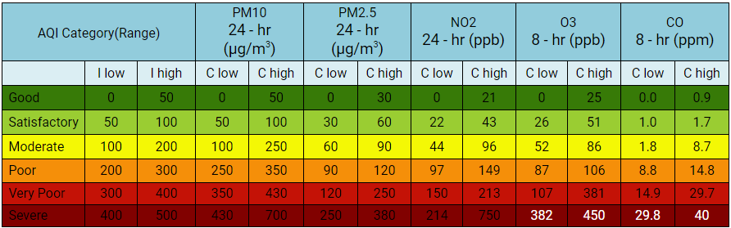

1. **Current solution to the problem**

Central Government is acting upon few projects and schemes to deal with air pollution:

* NCAP which aim to reduce PM2.5 levels by 2024.
* Comprehensive Action Plan (CAP) for actions identified for prevention, control and mitigation of air pollution.
* SAMEER app, wherein air quality information is available to public along with provision for registering complaints against air polluting activities.
* Crowd sourcing of innovative ideas/ suggestions/proposals from public is done through CPCB website

1. **Proposed solution to the problem**

* Invest in Clean Technology

Clean technology, that reduces negative environmental impacts through significant energy efficiency improvements, the sustainable use of resources, or environmental protection activities.

1. Set up a Money-lending firm or bank for people to convert their vehicles into CNG-run from petrol-run or diesel-run
2. Launch an Electric Carpool Startup

* Invest in Community-driven Change

1. Why do people not change their polluting vehicles?
2. Why do people not adhere to government regulations?
3. Why do people not want to carpool?

* Invest in Making Connections

Develop plans with corporations to help out as part of their CSR. Create accountability by keeping all transactions open and public.

1. **Reference to the problem**

System of Air Quality and Weather Forecasting And Research (SAFAR), Govt. of India.

1. **CRITICAL ASSESSMENT OF TOPIC SURVEY (50-100 words)**
2. **Find the key area, gaps identified in the topic survey where the project can add value to the customers and business**

Air pollution refers to the release of pollutants into the air that are detrimental to human health and the planet as a whole. Indian government has drawn NCAP, which needs close collaboration and cross-sectoral coordination among central ministries, state governments and local bodies. The aims of the plan align with existing policies and programs, including the National Action Plan on Climate Change, initiatives on electric vehicles, the Smart Cities Mission among others.

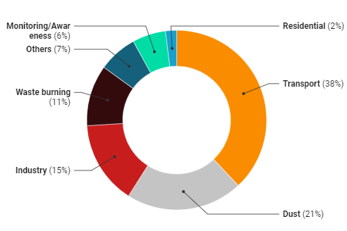

The diagram shows, NCAP is a long-term, time-bound, national level strategy to tackle the air pollution problem. to bring down levels of deadly particle air pollution (PM2.5 and PM10) by 20-30% by 2024 (from 2017 levels)

The project aims to suggest multi sector solution to Central bodies to build the new strategy plan for reducing air pollution.

1. **What key gaps are you trying to solve?**

After the analysis, the report can be shared with Central Body to provide some intervention for mitigation including, suspended road dust control, construction and demolition related dust, power sector and industrial emissions, transport sector emissions, agricultural emissions, emissions from unsustainable waste management practices. India’s air pollution challenge is complex and will require sustained, multi-sectoral approaches to be implemented over the long term. India cannot afford to delay action on air pollution.

1. 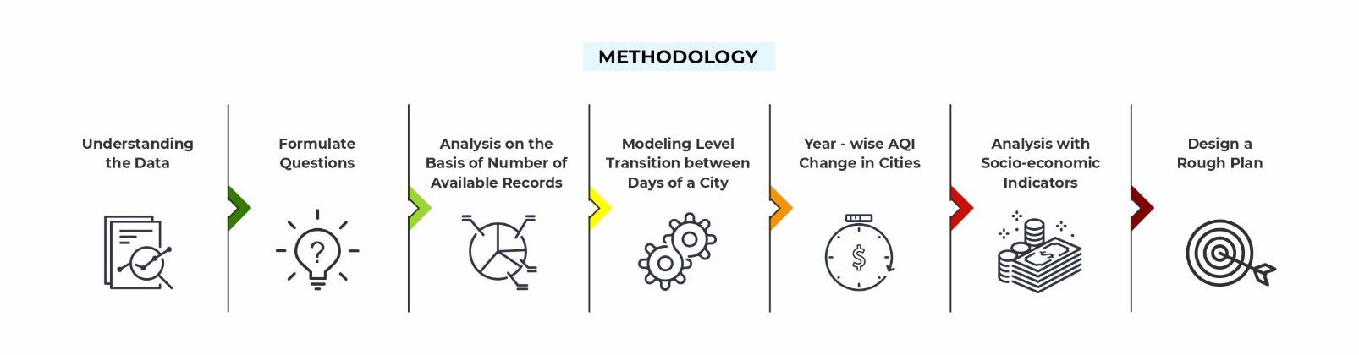**METHODOLOGY TO BE FOLLOWED (Explain each step from 1-5)**

**Step 1: Understanding the Data**

The 5 .csv datasets(city_day.csv, city_hour.csv, station_day.csv, station_hour.csv & stations.csv) were observed. Possible combinations of these datasets were realised.

**Step 2: Formulate Questions**

Questions other than the ones asked by the task author were formulated. An important idea that emerged from this step was to impute missing values using machine learning method, which doesn’t affect the original distribution of whole dataset.

**Step 3: Analysis on the Basis of Number of Available Records**

**Step 4: Modelling Level Transition between Days of a City**

**Step 5: Year-wise AQI Change in Cities**

The above 3 steps dealt with analysis on the AQI dataset.

**Step 6: Analysing with Socio-economic Indicators**

Combining other kinds of data to make a more rounded judgement of which city should receive the funding.

**Step 7: Design a Rough Plan**

Designing a rough plan suggesting idea to make improvements in the 3 chosen cities, the use of funds and a method to track progress.

1. **REFERENCES**
2. <http://safar.tropmet.res.in/AQI-47-12-Details>
3. <https://www.livemint.com/news/india/what-is-india-missing-in-its-battle-against-air-pollution-11606459726967.html>
4. <https://www.nrdc.org/stories/air-pollution-everything-you-need-know#sec1>
5. <https://cpcb.nic.in/displaypdf.php?id=aG9tZS9haXItcG9sbHV0aW9uL0dTUi03MTJFLnBkZg==>

**Notes for Project Team**

Sample Reference for Datasets (to be filled by team and mentor)

|  |  |
| --- | --- |
| Original owner of data | CPCB |
| Data set information | The dataset contains air quality data and AQI (Air Quality Index) at hourly and daily level of various stations across multiple cities in India. |
| Any past relevant articles using the dataset |  |
| Reference | The data has been made publicly available by the Central Pollution Control Board: https://cpcb.nic.in/ which is the official portal of Government of India. They also have a real-time monitoring app: https://app.cpcbccr.com/AQI_India/ |
| Link to web page |  |